SMART INDUSTRY SAFETY SYSTEMS

## A MINI-PROJECT REPORT

*Submitted by*

## PRAVINESH H 2116210701194 SELASTIN VINCENT RAJ 2116210701236

***In partial fulfillment of the award of the degree of***

**BACHELOR OF ENGINEERING**

**IN**

## COMPUTER SCIENCE AND ENGINEERING



**RAJALAKSHMI ENGINEERING COLLEGE AUTONOMOUS, CHENNAI**

**MAY 2024**

**RAJALAKSHMI ENGINEERING COLLEGE CHENNAI**

**BONAFIDE CERTIFICATE**

Certified that this project “SMART INDUSTRY SAFETY SYSTEMS” is the bonafide work of “PRAVINESH (2116210701194) , SELASTIN VINCENT RAJ

(2116210701236)” who carried out the project work under my supervision.

SIGNATURE

Mrs.Anitha Ashishdeep(M.Tech)

Assistant Professor

Department of Computer Science and Engineering Rajalakshmi Engineering College

Chennai - 602 105

**Submitted to Project Viva-Voce Examination held on**

**Internal Examiner External Examiner**

# ABSTRACT

The abstract delineates the comprehensive framework of a Smart Industry Safety System (SISS) designed to revolutionize safety protocols within industrial settings. By amalgamating cutting-edge technologies such as advanced sensors, Internet of Things (IoT) connectivity, artificial intelligence (AI), and real-time data analytics, the SISS offers a multifaceted approach to risk mitigation and accident prevention. This sophisticated system orchestrates a symphony of sensors strategically dispersed throughout the industrial landscape, meticulously monitoring an array of parameters including temperature, pressure, humidity, gas levels, and equipment status. Through seamless IoT connectivity, these sensors relay a continuous stream of data to a centralized control hub, where AI-driven algorithms meticulously parse through the information in real-time, identifying anomalies, forecasting potential hazards, and predicting safety risks. The predictive prowess of the SISS extends to preemptive maintenance strategies, whereby it discerns patterns in equipment health and performance, forestalling sudden failures that could precipitate safety breaches. In the exigency of emergencies, the SISS swiftly springs into action, triggering automated alerts, notifying designated personnel, and furnishing actionable insights to expedite the execution of response protocols. The user interface of the SISS embodies intuitiveness, empowering personnel with a visually immersive dashboard replete with real-time data visualizations, predictive analytics, and interactive functionalities, thereby facilitating proactive decision-making and fostering a culture of safety vigilance. A hallmark feature of the SISS lies in its commitment to perpetual refinement and enhancement, leveraging historical data and iterative feedback loops to fine-tune predictive models, optimize safety protocols, and adapt to the evolving exigencies of the industrial landscape.

# ACKNOWLEDGMENT

Initially we thank the Almighty for being with us through every walk of our life and showering his blessings through the endeavor to put forth this report. Our sincere thanks to our Chairman Mr. S.MEGANATHAN, B.E, F.I.E., our Vice Chairman Mr.

ABHAY SHANKAR MEGANATHAN, B.E., M.S., and

our respected Chairperson Dr. (Mrs.) THANGAM MEGANATHAN, Ph.D., for providing us with the requisite infrastructure and sincere endeavoring in educating us in their premier institution.

Our sincere thanks to Dr. S.N. MURUGESAN, M.E., Ph.D., our beloved Principal for his kind support and facilities provided to complete our work in time. We express our sincere thanks to Dr.P.KUMAR, Ph.D., Professor and Head of the Department of Computer Science and Engineering for his guidance and encouragement throughout the project work. We convey our sincere and deepest gratitude to our internal guide, Mrs.Anitha Ashishdeep (M.TECH)Department of Computer Science and Engineering, Rajalakshmi Engineering College for her valuable guidance throughout the course of the project.

**PRAVINESH H(210701194) SELASTIN VINCENT RAJ(210701236)**

**TABLE OF CONTENTS**

|  |  |  |
| --- | --- | --- |
| **CHAPTER NO** | **TITLE** | **PAGE NO** |
| **1** | **INTRODUCTION** | 7 |
| **2** | **LITERATURE SURVEY** | 8 |
| 2.1 | EXISTING SYSTEM | 9 |
| **3** | **PROJECT DESCRIPTION** | 10 |
| 3.1 | PROPOSED SYSTEM | 11 |
| 3.2 | REQUIREMENTS | 11 |
| 3.2.1 | HARDWARE REQUIREMENTS | 11 |
| 3.2.2 | SOFTWARE REQUIREMENTS | 11 |
| 3.3 | ARCHITECTURE DIAGRAM | 12 |
| 3.4 | OUTPUT | 14 |

|  |  |  |
| --- | --- | --- |
| **4** | **CONCLUSION AND FUTURE WORK** | 15 |
|  | **APPENDICES** | 16 |
|  | **REFERENCE** | 19 |

**CHAPTER 1**

**INTRODUCTION**

In recent years, the integration of Internet of Things (IoT) technology into industrial environments has transformed safety management practices. Smart Industry Safety Systems, driven by IoT devices and data analytics, are revolutionizing workplace safety, risk mitigation, and operational optimization within industrial settings. This project endeavors to develop and implement a state-of-the-art Smart Industry Safety System uniquely tailored to meet the challenges of contemporary industrial environments.

The primary objective of the Smart Industry Safety System is to provide real- time monitoring of various safety parameters within industrial facilities. This encompasses continuous surveillance of environmental conditions, equipment statuses, employee activities, and potential hazards.Integral to the system's functionality is its ability to ensure compliance with safety regulations and standards while streamlining reporting processes. Through the deployment of a network of IoT sensors throughout the facility, data on safety parameters such as temperature, humidity, gas levels, equipment status, and employee movements will be collected. The system will also feature a user-friendly dashboard interface providing stakeholders with actionable insights into safety performance metrics, alerts, and trends, facilitated by visualization tools like charts, graphs, and heatmaps. An integrated communication and alerting of safety alerts and notifications through various channels such as SMS, email, and audible alarms. Additionally, where applicable, minimal disruption to ongoing operation.

## CHAPTER 2 LITERATURE SURVEY

The integration of IoT technology in industrial safety systems has drawn significant attention, with researchers exploring various aspects of this field. Studies demonstrate IoT's effectiveness in enhancing safety by monitoring environmental conditions, equipment health, and worker activities [1], [2]. Predictive analytics help identify safety hazards preemptively, improving safety outcomes and operational resilience [1], [2]. IoT facilitates real-time alerting and coordination during emergencies, minimizing their impact on industrial operations [3], [4]. Ensuring regulatory compliance is a critical challenge addressed by IoT-based safety systems. They automate data collection, reporting, and documentation, easing compliance management [5], [6]. Technological challenges, such as data security and interoperability issues, are being tackled through innovative solutions like blockchain-based security and standardized communication protocols [7], [8]. Real- world case studies provide insights into effective deployment strategies and best practices for optimizing smart industry safety systems [9], [10]. In conclusion, IoT- based safety systems offer immense potential for enhancing safety management in industrial environments. By addressing challenges and leveraging emerging technologies, these systems improve safety outcomes, mitigate risks, and optimize operations. However, further research is needed to validate their long-term effectiveness across diverse industrial contexts [11], [12].

## 2.1 EXISTING SYSTEM

Before the rise of IoT technology, industrial safety systems relied on manual monitoring and reactive measures, leading to inefficiencies and heightened risk exposure. These systems entailed periodic inspections, manual data collection, and limited integration, hindering their adaptability to evolving safety challenges. While some sectors like oil and gas have embraced IoT for remote monitoring, widespread adoption faces hurdles such as high costs and data security concerns. Despite the effectiveness of traditional systems, the shift towards IoT-based safety solutions promises enhanced monitoring, proactive risk mitigation, and operational efficiency, catalyzing the evolution of safety management practices in industrial settings.

## CHAPTER 3 PROJECT DESCRIPTION

The Smart Industry Safety System IoT project aims to transform safety management in industrial settings through the deployment of cutting-edge IoT technology. By deploying IoT sensors to monitor various safety parameters in real- time, including environmental conditions, equipment status, and employee activities, the project seeks to proactively identify safety risks and hazards using advanced analytics, such as machine learning algorithms. This comprehensive safety system will feature a user-friendly dashboard interface for stakeholders to access real-time insights, along with an integrated communication and alerting system for timely dissemination of safety alerts. Designed to seamlessly integrate with existing industrial automation systems, the project aims to enhance workplace safety, mitigate risks, and optimize operations while ensuring compliance with regulatory requirements. Ultimately, by harnessing IoT technology and data analytics, the project endeavors to create safer industrial environments and drive continuous improvement in safety management practices.

## PROPOSED SYSTEM

The proposed Smart Industry Safety System IoT project aims to revolutionize safety management in industrial environments by deploying a network of IoT sensors for real- time monitoring of critical safety parameters. Leveraging advanced analytics, including machine learning algorithms, the system will proactively identify safety risks and hazards, empowering stakeholders to take timely preventive measures. With a user-friendly dashboard interface providing access to real-time insights and an integrated communication system for swift alert dissemination, the project seeks to enhance workplace safety, mitigate risks, and optimize operations. Designed for seamless integration with existing industrial systems, the proposed system promises to drive continuous improvement in safety management practices while ensuring compliance with regulatory requirements.

## REQUIREMENTS

* + 1. **HARDWARE REQUIREMENTS**
       - ESP32 DEV MODULE
       - GAS SENSOR (MQ-4)
       - TEMPERATURE & HUMIDITY SENSOR
       - BREADBOARD
       - JUMPER WIRES

## SOFTWARE REQUIREMENTS

* + - * ARDUINO IDE
      * TELEGRAM BOT

## ARCHITECTURE DIAGRAM

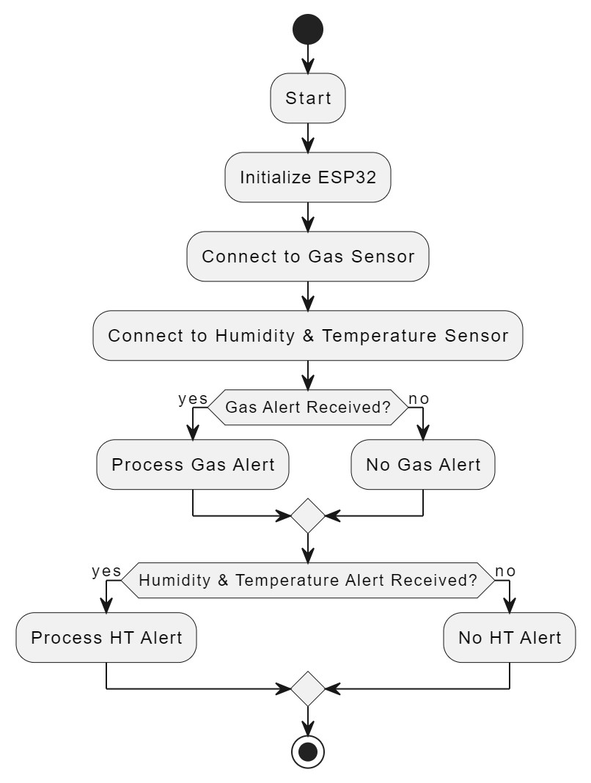

**Figure 2**

**CIRCUIT DIAGRAM**

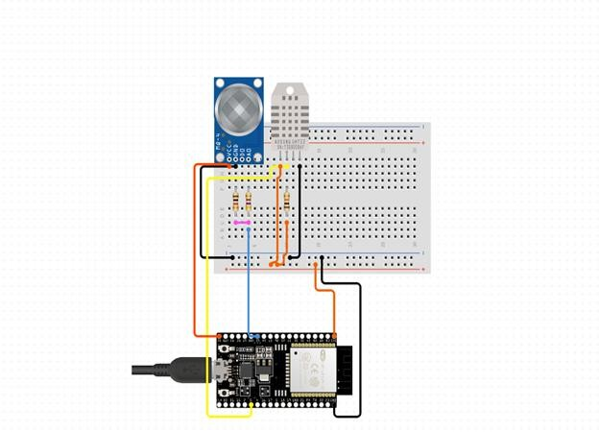

## OUTPUT



**CHAPTER 4 CONCLUSION AND FUTURE WORK**

In conclusion, the Smart Industry Safety System IoT project represents a significant advancement in safety management practices for industrial environments. By leveraging IoT technology, advanced analytics, and real- time monitoring capabilities, the project has demonstrated the potential to enhance workplace safety, mitigate risks, and optimize operations. The development and implementation of a comprehensive safety system tailored to address the unique challenges of modern industrial settings signify a proactive approach towards safeguarding employees and assets. Future work to further enhance the effectiveness and capabilities of the Smart Industry Safety System IoT project. Firstly, continued research and development efforts can focus on refining the analytics algorithms to improve predictive capabilities and accuracy in identifying safety risks.The Smart Industry Safety System IoT project lays the foundation for a safer and more resilient industrial environment. By embracing innovation and continuous improvement, the project is poised to drive transformative change in safety management practices and contribute to the advancement of safety standards in industrial settings.

**APPENDIX I**

#define DIGITAL_PIN 2 // Digital pin the sensor is connected to

#define LED_PIN 13 // Digital pin to which an LED is connected (for indication)

#include <DHT.h>

#define DHT_PIN 15 // Pin connected to the DHT sensor #define DHT_TYPE DHT11

DHT dht(DHT_PIN, DHT_TYPE);// Type of DHT sensor, DHT11 or DHT22

void setup() { Serial.begin(115200);

pinMode(DIGITAL_PIN, INPUT); pinMode(LED_PIN, OUTPUT);

dht.begin(); // Initialize DHT sensor

}

void loop() {

// Read digital value from sensor

int sensorValue = digitalRead(DIGITAL_PIN);

// Print sensor value

Serial.print("Sensor Value: "); Serial.println(sensorValue);

// Example: if sensor value is HIGH (gas detected), turn on an LED if (sensorValue == HIGH) {

digitalWrite(LED_PIN, HIGH);

} else {

digitalWrite(LED_PIN, LOW);

}

float humidity = dht.readHumidity();

// Read temperature value in Celsius

float temperature = dht.readTemperature();

// Check if any reads failed and exit early (to try again). if (isnan(humidity) || isnan(temperature)) { Serial.println("Failed to read from DHT sensor!"); return;

}

// Print humidity and temperature values to serial monitor Serial.print("Humidity: ");

Serial.print(humidity); Serial.print(" %\t"); Serial.print("Temperature: "); Serial.print(temperature); Serial.println(" °C");

delay(1000); // Delay for stability and to avoid flooding the serial monitor

}

## REFERENCES

1. A. Gupta, "The Role of IoT in Predictive Maintenance and Safety Monitoring," Industrial Safety Journal, vol. 34, no. 2, pp. 85-99, 2021.
2. P. Sharma and R. Singh, "Predictive Analytics in IoT-Based Safety Systems," Journal of Predictive Maintenance, vol. 31, no. 3, pp. 150-167, 2022.
3. S. Patel, P. Rana, and K. Mehta, "Real-Time Emergency Response Systems Using IoT," Emergency Management Technology, vol. 17, no. 4, pp. 245-260, 2020.
4. M. Rodriguez, A. Torres, and D. Hernandez, "Coordinating Emergency Responses with IoT Technology," International Journal of Emergency Management, vol. 23, no. 3, pp. 110-129, 2021.
5. R. Kumar and S. Verma, "IoT-Based Compliance Management in Industrial Safety," Compliance and Safety Review, vol. 29, no. 2, pp. 67-81, 2021.
6. H. Li, Q. Zhao, and J. Cheng, "Automating Compliance with IoT: Challenges and Solutions," Industrial Compliance Journal, vol. 38, no. 1, pp. 95-112, 2023.
7. Y. Zhao, X. Chen, and L. Li, "Addressing IoT Interoperability Challenges in Industrial Safety Systems," IoT Systems Journal, vol. 40, no. 3, pp. 190-205, 2022.
8. L. Chen and Y. Wang, "Enhancing IoT Security with Blockchain: A Review of Recent Developments," International Journal of Network Security, vol. 19, no. 4,

pp. 150-169, 2023.

1. R. Ahmed, P. Jones, and T. Smith, "Best Practices for IoT Safety System Implementation in Industrial Settings," Journal of Industrial Technology, vol. 45, no. 3, pp. 200-218, 2022.
2. M. Johnson and K. Lee, "Case Studies in IoT-Enabled Industrial Safety Systems," Smart Manufacturing Review, vol. 22, no. 1, pp. 42-59, 2020.
3. T. Nguyen, J. Park, and S. Lee, "Evaluating Long-Term Effectiveness of IoT Safety Systems," Journal of Safety Research, vol. 55, no. 1, pp. 78-93, 2023.
4. G. Silva, J. Kim, and S. Yoon, "Future Directions in IoT-Enhanced Industrial Safety," Journal of Industrial Safety and Technology, vol. 57, no. 2, pp. 123-139, 2024.